Week 3: Gastrulation and Trilaminar Disc Formation

Key Timeline and Events
- Day 15 (Gastrulation Onset):
  - Primitive streak forms caudally in epiblast (BMP4/Wnt signaling from extraembryonic tissues)
  - Epiblast cells ingress as mesendoderm precursors
  - Bilaminar disc elongates to pear-shaped (~1 mm).
- Days 16-17 (Streak Elongation and Notochord):
  - Streak extends cranially
  - Primitive node (cranial end) organizes notochord process (midline mesoderm)
  - Prechordal plate thickens cranially (head organizer)
  - Caudal eminence forms at streak tail.
- Days 18-19 (Trilaminar Disc Establishment):
  - Ingression displaces hypoblast → definitive endoderm
  - Lateral plate mesoderm splits into somatic and visceral layers
  - Neural plate induces from ectoderm (notochord SHH signals).
- Days 20-21 (End of Week 3):
  - Streak regresses
  - Somites begin forming from paraxial mesoderm (segmentation clock via Notch or Delta).
  - Oropharyngeal membrane (buccopharyngeal) and cloacal membrane appear as ectoderm-endoderm junctions
  - Allantois buds from caudal endoderm
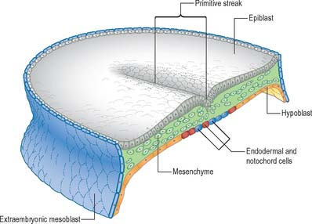

Key structures formed
Primitive Streak: Transient groove in epiblast (caudal to rostral). Site of gastrulation ingress. Primitive node (thickened cranial end) → notochord.

Trilaminar Germ Disc:
Ectoderm: Neural plate (dorsal, future CNS/PNS); surface ectoderm (epidermis).
Mesoderm: Paraxial (somites: vertebrae/muscles), intermediate (kidneys/gonads), lateral plate (somatic: body wall; visceral: gut serosa).
Endoderm: Definitive (gut lining, respiratory); yolk sac remnants.

Notochord: Rod-like midline structure from Hensen's node; induces neural tube, defines body axis.
Prechordal Plate: Cranial thickened epiblast/mesendoderm; secretes SHH for forebrain induction.
Membranes: Buccopharyngeal (cranial, future mouth); cloacal (caudal, future anus/urogenital); allantois (vascular outpouching for umbilical cord precursor).

